Student name
Instructor
Course
Date

Quality management and continuous improvement on the check in check out hotel system
Abstract
A hotel with an advanced check in check out system is likely to attract more customers. Hotel Escargo chain had developed an earlier system that was used to book customers in and out of the hotel. It was discovered that the system was not effective and efficient and hence improvement was needed to cater for all the operations and ensure that customers are served efficiently by the new system. The new check in check out system was supposed to please visitors seeking a place to spend in their journey, offer an improved services and provide a friendly environment to employees and the visitors in the hotel. It was noted that the check in check out system was to be the backbone of the hotel and hence improvement was a key implementation of the management. Check in check out system used in the past was not effective and provided room for errors, and hence the hotel incurred losses arising from omissions.

Introduction
To ensure that the new system was up and running, different components were integrated together to ensure that each visitor visiting Hotel Escargo chain would be satisfied by the new check in check out system. However, each customer had varying needs, and keeping with the need for each visitor was hard to the system developer. Central points were picked which included the major need for each customer. With these points, it was easy for the developer to come up with a system that would cater for the need of each customer in the new check in check out system. With the achievement of this milestone, the hotel was now ready to handle the need of each customer satisfactorily.

Features of the new check in check out system
When the customers will be able to check in the hotel
With the new check in check out system, the customers will be able to check in the hotel from 14000 hours. The check-in time will not be fixed to offer flexibility to customers. Also, the system will be able to notify the customers who might be sunbathing or getting themselves to the hotel when the rooms are ready for the tidying process (Wang, 2016). The charges will be appended to the receipt and hence reducing the time that the customers were wasting with the new system. Also, the check in check out system will be appended directly to the hotel website and hence searchable very quickly when needed.
Cookies and sessions will be used to offer clients an easy time to log into the website in a friendlier manner. The use of the SEO will be enhanced so that the check in check out module will be visible by the click of the first three letters of the system. The check-in process will be done online at convenient customer time. However, the hotel will maintain a 24hrs support system that will ensure that the customers get the response immediately after enquiring. By this, there will be improved communication, and many customers will be enticed to use the hotel services more frequently when needed.
When the customers can check out of the hotel
The average check out time will be 12000hours. This is the automatic time that has been set by the system. Although the time will be flexible to give the visiting an ample time to pack out of the hotel to their various destinations. Same to the check-in system, check out will use cookies and sessions will be used to store client’s information and accessed when needed. It will be agreed by the customers whether they need to pay the full amount when checking into the
System or the payment should be made in half. One half when checking in and the second half when checking out.
This will be flexible, and hence the customers will have an easy time accessing the hotel with either half payment or full payment depending on the customer pocket. The checkout system will be online, and hence customers will not be required to line up on the reception to clear their room as it was with the old check in check out system used by the hotel.
From a different meeting held in the hotel, it was agreed that the online check in check out system would have several advantages which cannot be ignored and hence the need to have a new check in check out system to achieve the underlying advantages (Melián-González, 2016). One of the underlying advantages is ease of making the booking and checking out business. Quick to implement the system. It will only require the need of the customer accessing the website and making the necessary requests and later waiting for the final feedback. Another appended advantage is that the system will provide a digital receipt by email hence a paperless transaction. A paperless transaction is recommended as errors incurred are minimal or completely no errors in the system.
The checkout system will work as follows; the customers will be required to issues a departure time a day before the actual departure time. This will allows the management to plan well and issue the required receipt through email in time. After the departure time has been indicated a text message will be sent to the customer who will use the link to the actual checking out system (Yoo, 2015). This will enable the customer to view the bills, the purchases made while in the hotel and making the necessary adjustment if needed. After complete payment, the customers will be issued with the final receipt in the form of a PDF.
The receipt is an evidence of the complete transaction in the hotel and can be used later to earn redeemable points in the hotel when offer arises. The system will ensure that any form of payment is acceptable and the customers can be able to use their available credit and debit cards to make payment. It should be noted that the new system will limit the use of cash and employ the use of cards since the era we are living in is a cashless economy. With cards there will be reduced customer theft and complains will also be reduced. Hotel Escargo chain will be able to achieve the set goals and hence improvement will be crucial to both the management and the clients.
Requirements for the new system
The requirement for the new check in check out system will be grouped into two: the functional and the non-functional requirement.
Functional requirement
- The system will be able to support the booking and modify these customers.
- The ability of the customer to search Hotel Escargo chain with ease through the use of SEO.
- The ability to cancel booking when an urgent need arises and later continue with the booking later. This will offer increased flexibility.
- The staff should be able to edit customers’ details and provide feedback.
- The ability to use credit and debit cards.
- The system should be able to send a confirmation email immediately the booking procedure has been completed.
- The customers have a section that they can write a review and improvements that can be made to the hotel in a friendly tone.
- The system should provide the customers the ability to check the latest promotions available in the hotel.

Non-functional requirements.
- The system should be able to transfer data from the customer credit and debit cards to the main hotel account.
- Multiple transactions should be handled by the customer at once.
- The booking services will be provided all round the clock.
- The system will be multi-browser oriented to allow each customer to use their favorite browsers.
- The system should have a plugin that will facilitate the sending of the newsletter to the clients at all times.
UML (Unified Modelling Language) design
These are designs that will be implemented in the new check in check out system. They include:
- Class diagram
- Use case diagram
- Check available.
- Payment class.
- Confirmation class.

Class diagram
This is one of the most used classes in the UML diagram. It is the main building block as well as the fact that the class offers an object-oriented solution. The class shows how the system attributes should be divided to offer an ultimate checking in and checking out a system to the customers (Zygourakis, 2014). The diagram below shows a class diagram that has been used to model the new check in and check out the system.
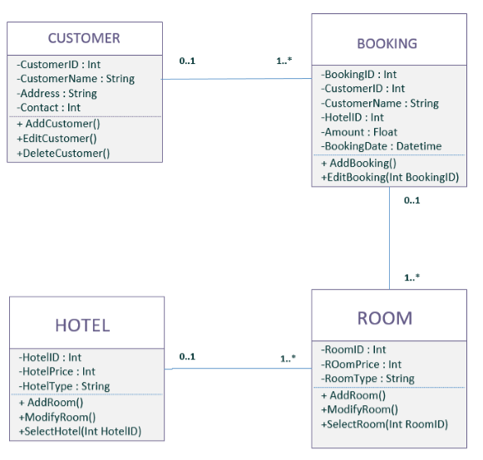
(Image courtesy of Datacom.modifeyers)

Use case diagram
This forms the behavioral UML diagram. Shows the exact behavior of the expected system as well as the manner in which the system will interact with the users. Different functional needs are shown in this class. The diagram below shows the use case diagram implemented in the hotel.
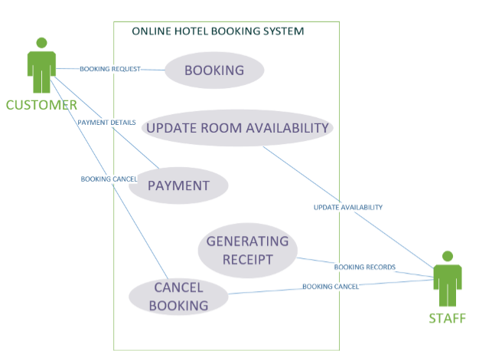
(Image courtesy of hotelier managers.com)
As shown in the diagram, all the customer functional requirements will be highlighted under the use case module.

Checking in available
Under this, the customer will first be required to search for the available booking before making the actual booking. This is necessary as the customer will be able to select the best booking available in the hotel with the best prices. 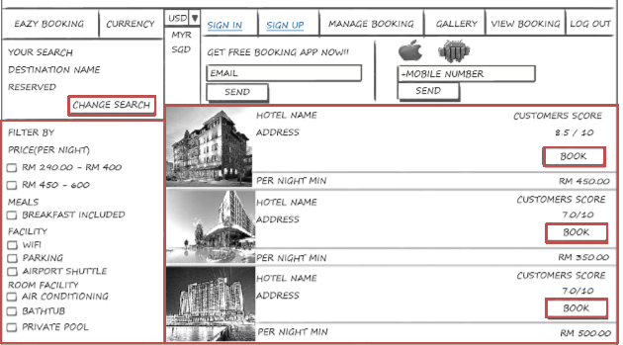
(Image courtesy of gooddatamodifeyers.com)
Payment
Under this section, the customer is required to commit to payment upon selecting the services available. The customers are required to make payment using the debit and credit cards. The system will only take accurate data, and hence the customer is advised to be keen under this section because any error discovered will be automatically detected, and the system might lock the application for security reasons. After the correct details have been entered, then proceed button should be clicked hence completing the payment procedure. The customer is also advised to key in the correct email because the email confirmation will be required by the hotel.
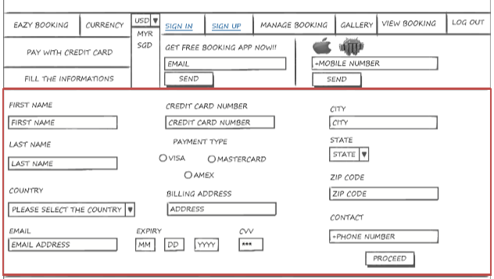
(Image courtesy of gooddatamodifeyers.com)

Payment details
This section prints on the screen the details entered by the customer. This provides a second chance to error correction under the edit button. After any editing has been made, then proceed button is clicked which automatically direct the customer to the confirmation section to confirm the entered details. 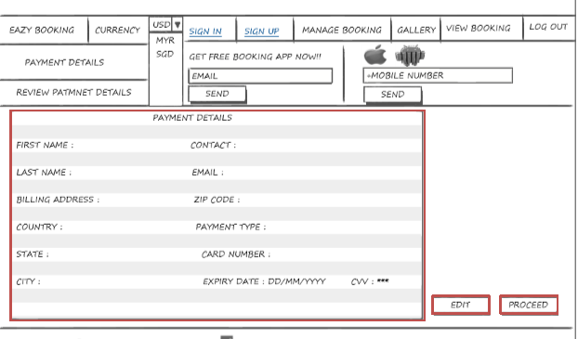
(Image courtesy of gooddatamodifeyers.com)
Implementation
Once the system is complete, the implementation process is very important as it allows the testing process to ensure that the system can work in any environment. The system will require the use of an operating system including, windows (7, 8, 10), Mac or OSX. The browser usable includes Google, Chrome, Internet Explorer and the latest version of Mozilla Firefox. To store data, the data management system used will be MySQL server, Microsoft Access, and Oracle. The system cannot run on software platform only, hence hardware component including, RAM minimum of 1GB, HDD with at least 500GB capacity, Processor at least Intel Pentium latest and internet either wireless or wired network.
Limitation incurred by the improved check in check out system
- Used when the customer is connected to the internet.
- The customer must have a laptop or smartphone to access the system.
Conclusion
The system will have limitless benefits to the customers who are ready to embrace change. Under the home page, the customer will only be required to check available services through the use of the email either through the use of the phone or any other gadget. Payment will be made possible without the customer having to access the physical location of the hotel. This is similar to reservation process where customers will have an easy time making any reservation at their homes before the actual day. The checkout system is quite direct, and customers will be able to direct any query that might arise while checking out of the hotel.
Group portion
Apply six-sigma quality standard and devise a plan for the hotel to monitor and control future process performance.
Control phase in the DMAIC process
This marks the conclusion of the team’s journey. This is determined by the performance that has been established throughout the quality management process (Fırat, 2017). At this stage, different stakeholders are rewarded depending on the work done in the already completed project. At the end of the project, there is a need to leave a positive remark that can be used as a development plan for future projects.
Control roadmap
Tin hotel management setup, the control process was adopted to ensure that each step has been covered. The control phase acts as the checkpoint where all the phases are brought to board with the aim of cross-checking each step before presenting the final product to the hotel management staff (Berg, 2015). The chart below shows part of the control phase that was used in the hotel setup.
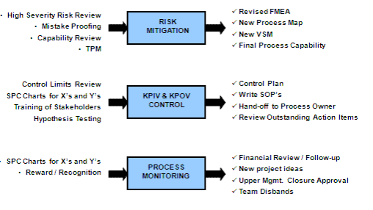
Each step in the phase is equally important because the hotel has to implement risk mitigation, approval and monitor the processes as well. There must be enough emphasis that needs to be done in each step. This makes it easy as the energy required for each step will be limited, and the management will have an easy time to implement the check in checkout system.
Under the control phase, the following ought to be done to ensure a successful conclusion of the project.
- Defining the processing capacity
- Closing the project successfully
- Communicating with the management as well as the celebration for a successful project.

Reference list
Wang, D., Xiang, Z., Law, R., & Ki, T. P. (2016). Assessing hotel-related smartphone apps using online reviews. Journal of Hospitality Marketing & Management, 25(3), 291-313.
Chen, M. M., Murphy, H. C., & Knecht, S. (2016). An importance performance analysis of smartphone applications for hotel chains. Journal of Hospitality and Tourism Management, 29, 69-79.
Melián-González, S., & Bulchand-Gidumal, J. (2016). A model that connects information technology and hotel performance. Tourism Management, 53, 30-37.
Yoo, S., Lee, K. H., Baek, H., Ryu, B., Chung, E., Kim, K., ... & Hwang, H. (2015). Development and user research of a smart bedside station system toward patient-centered healthcare system. Journal of medical systems, 39(9), 86.
Zygourakis, C. C., Rolston, J. D., Treadway, J., Chang, S., & Kliot, M. (2014). What do hotels and hospitals have in common? How we can learn from the hotel industry to take better care of patients. Surgical neurology international, 5(Suppl 2), S49.
Farrington, T., Antony, J., & O'Gorman, K. D. (2017). Continuous improvement methodologies and practices in hospitality and tourism. International Journal of Contemporary Hospitality Management, (just-accepted), 00-00.
Patel, M. T. (2017, February). Six Sigma in Service Organization–A Critical Review. In Proceedings of International Conference on Emerging Trends in Mechanical Engineering.

